## Abstract

This capstone project, conducted as part of the Master of Science in Business Analytics program at the University of California, Irvine, aimed to integrate academic learning with industry practice by addressing real-world data science challenges. Partnering with Pacific Life Insurance Company, the project focused on leveraging data analytics to enhance investment decision-making by better understanding and predicting macroeconomic trends.

Key objectives included deriving actionable insights for navigating financial markets and improving the prediction of macroeconomic trends. The project employed data analysis and modeling techniques, including Random Forest, ARIMA, LSTM, and Prophet models, to forecast key economic indicators. The resulting interactive dashboard showcased key economic trends and provided strategic recommendations for investment decisions, including focusing on growth stocks in technology and consumer discretionary sectors and hedging against inflation by increasing holdings in TIPS and real assets. Overall, the project enhanced Pacific Life's understanding of macroeconomic trends and improved investment decision-making through the dashboard and predictive models.

Table of Contents

Abstract 1

1. Introduction 3

Project Objectives 3

Key Questions 3

Deliverables 3

2. Data Description and Visualization 4

Data Sources 4

Data Visualization 4

Insights from Visualizations 4

3. Dashboard 5

Introduction 5

Key Features and Functions 5

Overall Benefit to the Company 5

4. Forecast Model 6

Machine Learning Approach 6

Statistical Approach and Code Explanation 9

5. Implications and Recommendations 12

Strategic Recommendations 12

Potential Impact on Client Organization 12

6. Conclusion 12

## 1. Introduction

### Project Objectives

This project aims to leverage advanced data analysis and modeling techniques to enhance our understanding and prediction of macroeconomic trends, thereby improving navigation in the financial markets. By utilizing sophisticated analytical methods, we strive to transform raw data into meaningful information that can guide investment strategies. Our objective is to empower investors with tools and insights that facilitate a deeper comprehension of market dynamics and future economic conditions, ultimately aiding in more informed investment decisions.

### Key Questions

1. **How can we effectively gauge macroeconomic trends?**

To gauge macroeconomic trends effectively, we segmented key economic variables and created an interactive dashboard. This approach provided a clear view of the economic landscape by highlighting relevant indicators. Our deliverable was an intuitive dashboard for users to explore and understand these trends, aiding decision-making in financial markets.

1. **What is the current direction of the US economy?**

Our approach to determining the current direction of the US economy involved analyzing historical data to identify patterns and trends. This analysis incorporated various statistical and machine learning models to generate reliable forecasts. The deliverable included forecast models and a dashboard demonstrating these trends, providing users with a visual representation of the economic outlook.

### Deliverables

The project delivers three main components:

* An interactive dashboard for visualizing key economic variables, facilitating intuitive exploration of macroeconomic trends.
* Implementation of predictive models (Random Forest, ARIMA, LSTM, and Prophet) for forecasting economic indicators and trends.
* Strategic recommendations derived from data analysis and predictive modeling insights, aiding navigation of financial markets.

## 2. Data Description and Visualization

### Data Sources

**Bloomberg**: For real-time financial data acquisition. Bloomberg provides up-to-date and comprehensive financial data, ensuring that our analyses are based on the most current market conditions. This data includes real-time prices, trading volumes, and other critical financial metrics essential for accurate and timely economic forecasting.

### Data Visualization

1. **Initial Dashboards**: Created using Tableau for initial data exploration. These dashboards provide a user-friendly interface to explore data visually, allowing for the identification of basic trends and outliers. Tableau's drag-and-drop features enable quick creation of charts and graphs, making it easier to understand the data at a glance.
2. **Enhanced Visualizations**: Developed using Python for detailed analysis, including heat maps and line charts. Python’s capabilities allow for the creation of more complex and customized visualizations that can handle large datasets and intricate data relationships. Heat maps are used to show the intensity of data points over a geographical area or a matrix of values, while line charts effectively illustrate trends over time.

### Insights from Visualizations

* **Economic Indicators**: Highlight trends and correlations among variables such as GDP, CPI, and unemployment rate. Visualizations help to reveal relationships and interactions between different economic indicators, providing insights into macroeconomic trends. For instance, a line chart might show the correlation between rising GDP and decreasing unemployment rates, helping to forecast future economic conditions.
* **Interactive Elements**: Allow stakeholders to explore data and identify patterns over different time frames. Interactive elements such as sliders, drop-down menus, and clickable graphs enable users to filter data by date ranges, sectors, or specific economic indicators. This functionality makes it easier for stakeholders to conduct a detailed analysis and tailor their insights to specific periods or conditions, facilitating more informed decision-making.

## 3. Dashboard

### Introduction

The dashboard designed for Pacific Life Insurance Company serves as an advanced tool to visualize and analyze key economic indicators across multiple sectors. This tool enhances the company’s ability to evaluate economic trends, aiding in making informed investment decisions by comparing various economic indicators.

### Key Features and Functions

#### Sector Selection:

Users can choose from six major economic sectors: Consumer Sentiment, Finance, Housing, Inflation, Labor Market, and Production. This allows for targeted analysis, enabling users to focus on specific areas of interest or concern. By narrowing down to a particular sector, the dashboard facilitates a more detailed and relevant examination of economic trends and indicators.

#### Variable Selection within Sectors:

Within each sector, users can select specific variables to visualize. For example, in the Consumer Sentiment sector, users might choose the "Conference Board US Leading Index Average Consumer Expectation." This feature provides flexibility and specificity, allowing users to drill down into particular data points that are most relevant to their analysis. It helps in gaining deeper insights into the selected economic indicators.

#### Interactive Graphs and Charts:

The dashboard includes interactive graphs where users can view data trends over time. The x-axis represents dates, and the y-axis represents the values of the chosen economic indicator. Interactive visualizations make complex data more accessible and understandable. Users can identify trends, patterns, and anomalies at a glance, facilitating quicker and more accurate decision-making.

#### Data View Option:

Users can switch between graphical and tabular data views. This dual representation caters to different user preferences, whether they prefer visual graphs for trend spotting or detailed tables for precise data points. It enhances the usability of the dashboard by providing comprehensive data analysis options.

### Overall Benefit to the Company

The dashboard is an invaluable tool for Pacific Life Insurance Company, offering an interactive and user-friendly platform to visualize and analyze economic indicators. By leveraging this dashboard, the company can improve its understanding of economic trends, make data-driven investment decisions, and navigate financial markets more effectively.

## 4. Forecast Model

In an attempt to create a forecast model that can predict recessions, we took two approaches: 1. Machine Learning Approach, and 2. Statistical Approach.

### Machine Learning Approach

For the machine learning approach, we utilized a random forest model to predict recessions. The data used included various economic indicators, summarized as follows:

|  |  |
| --- | --- |
| * Recession_NBER | * Personal Income |
| * GDP | * University of Michigan Consumer Sentiment |
| * Industrial Production | * New Housing Units |
| * CPI/ Core CPI | * Conference Board Building Permits |
| * PPI/ Core PPI | * National Financial Conditions Index |
| * PCE/ Core PCE | * St.Louis Fed Financial Stress Index |
| * Unemployment Rate | * People Working Part Time |
| * Nonfarm Payrolls |  |

#### Mutual Information

To better capture the predictive power of our features in relation to recession periods, we calculated mutual information by shifting the 'Recession_NBER' target variable. Mutual information measures the amount of information one variable contains about another variable. High mutual information values indicate a strong relationship between the feature and the target variable, suggesting that the feature is informative for predicting recessions. The mutual information analysis with shifted 'Recession_NBER' demonstrates that key indicators such as GDP, CPI, and the unemployment rate consistently exhibit high mutual information values, reaffirming their importance in recession prediction.

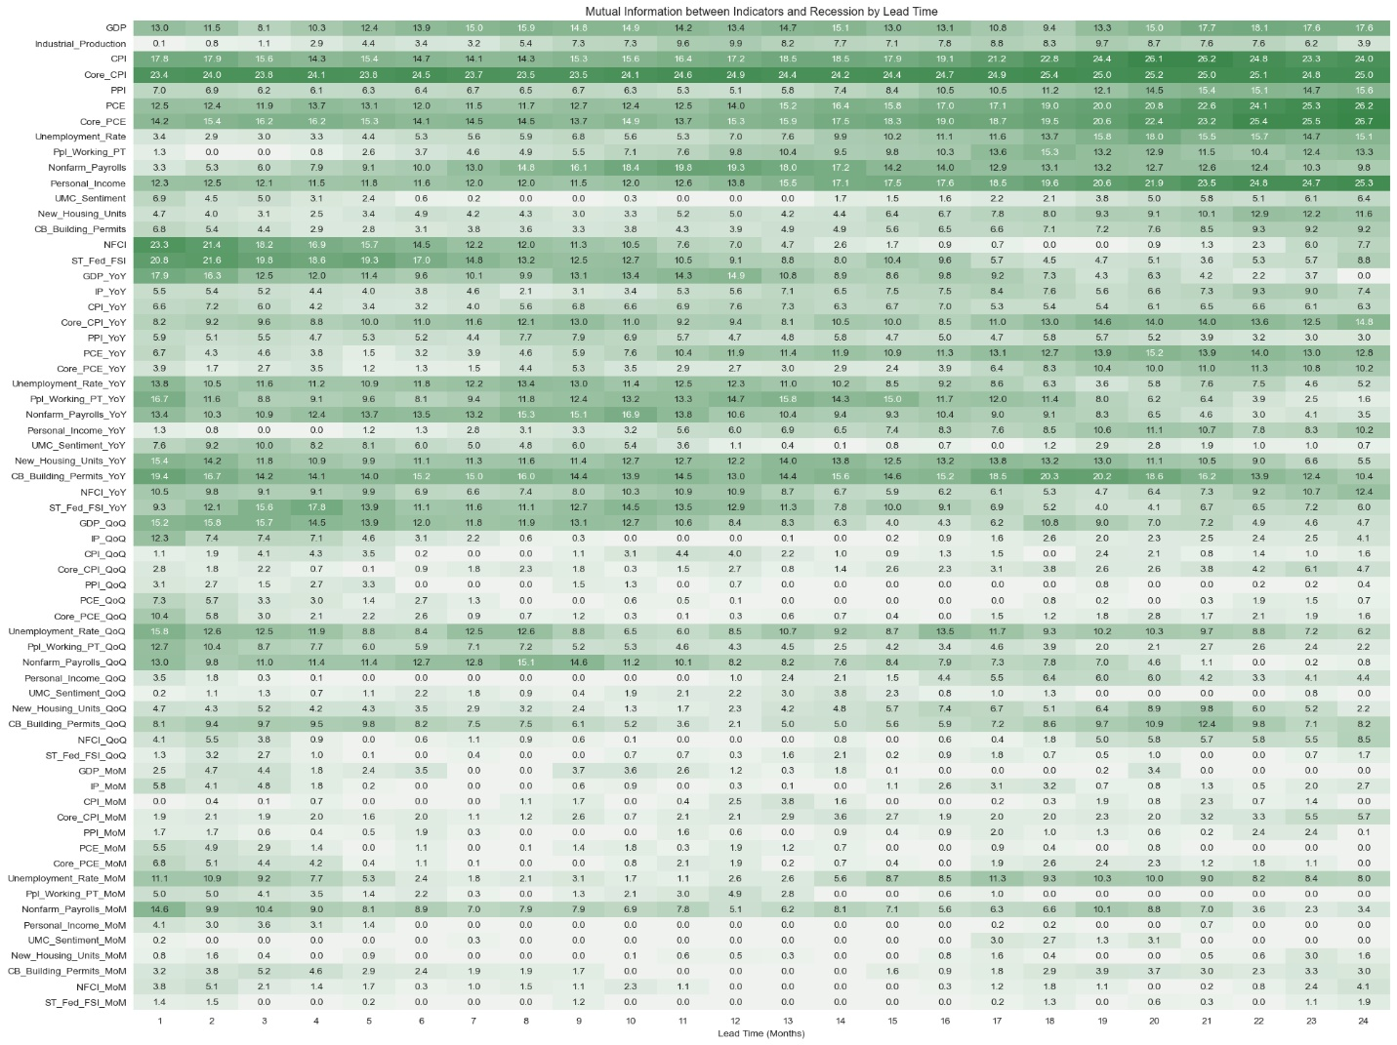

#### Feature Importance

In addition to mutual information, we calculated feature importance using a Random Forest classifier. We created a heatmap to visualize the feature importance values across different lead times. This heatmap illustrates the strength of relationship between each feature and the recession indicator for various lead times. Similar to mutual information, the feature importance analysis with shifted 'Recession_NBER' demonstrates that key indicators such as GDP, CPI, and the unemployment rate consistently exhibit high importance values, reaffirming their significance in recession prediction.

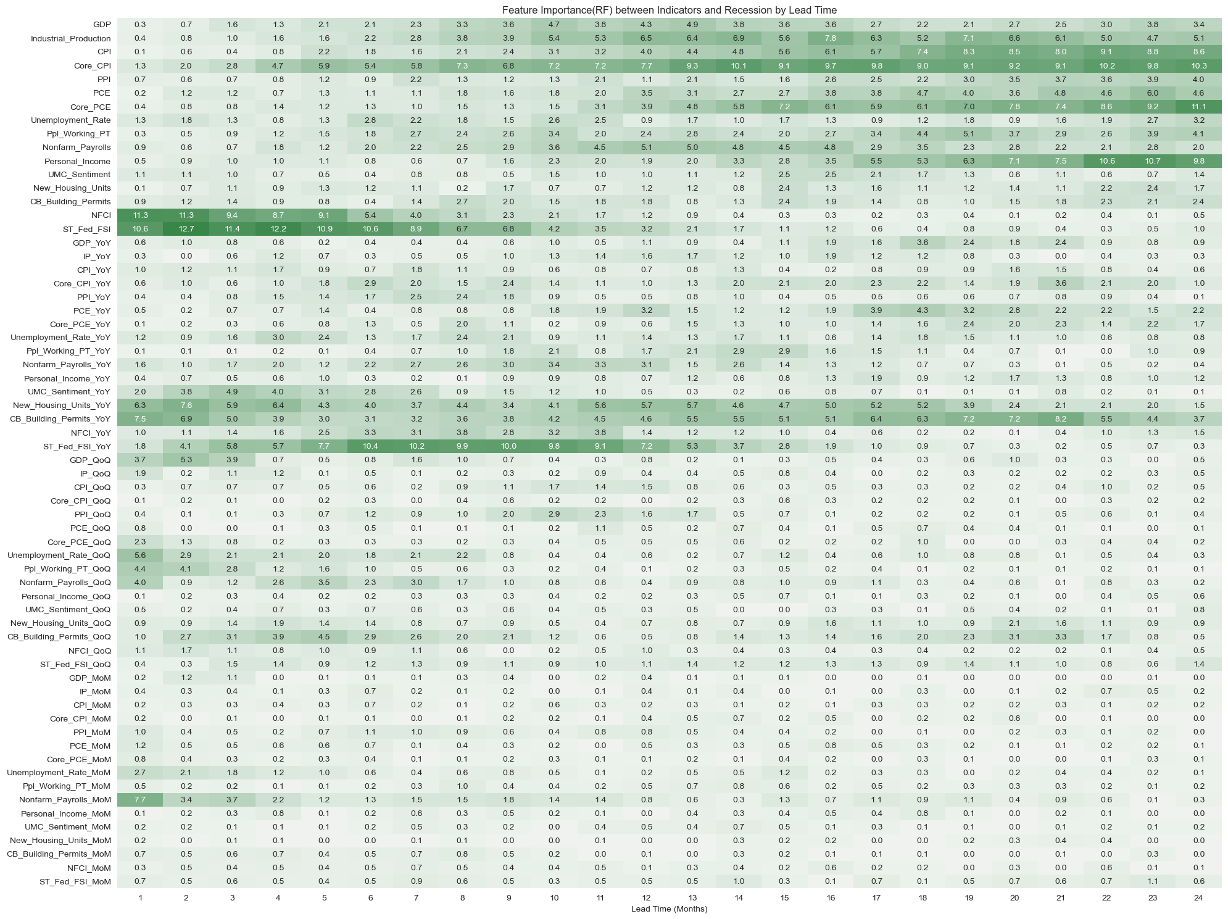

#### Model Training and Results

Using the Random Forest model, we achieved high accuracy in predicting recessions. However, we encountered issues of overfitting, primarily due to the imbalanced nature of the data, with fewer instances of recessions compared to non-recession periods.

To address the imbalanced data issue, we assigned a higher weight to the recession class, resulting in an improved recall for the class. Despite these adjustments, several limitations persisted:

1. **Imbalanced Data:** The model was biased towards the non-recession class due to the disproportionate number of non-recession periods compared to recession periods.
2. **Temporal Dependencies:** The time series nature of the data was not fully leveraged, which could impact the model's predictive power.
3. **Low Interpretability:** Random Forest models are inherently complex, making it difficult to understand the relationship between features and predictions.

These limitations prompted us to explore a second approach: the Statistical Approach.

### Statistical Approach

For the statistical approach, we employed ARIMA, LSTM, and Prophet models to forecast GDP, Fed Rates, CPI, and the unemployment rate. These models leverage historical data and advanced algorithms to generate precise forecasts. For ARIMA, we fitted time series data to autoregressive integrated moving average models. LSTM, a type of recurrent neural network, was employed to capture long-term dependencies in sequential data. Prophet, developed by Facebook, incorporates seasonality and holiday effects into its forecasts.

Following the generation of forecasts from ARIMA, LSTM, and Prophet models, their performance was evaluated to determine the most accurate predictor for our case. This evaluation involved plotting the forecasts from each model and conducting a comparative analysis using the Root Mean Squared Error (RMSE) metric. Given its low RMES values, we have elected to utilize the ARIMA model for generating forecasts in our analysis.

**CPI and Federal Rates Forecasting:**

**CPI**

* **Growth:** The CPI is expected to continue its upward trend, reaching 319.18 by December 2024. This consistent increase suggests inflationary pressures persisting, though at a steady rate.

CPI FORECASTED VALUES BASED ON ARIMA

|  |  |
| --- | --- |
| Date​ | Forecasted CPI​ |
| 2024-5​ | 314.02​ |
| 2024-6​ | 314.79​ |
| 2024-7​ | 315.51​ |
| 2024-8​ | 316.22​ |
| 2024-9​ | 316.98​ |
| 2024-10​ | 317.74​ |
| 2024-11​ | 318.48​ |
| 2024-12​ | 319.18​ |

**Federal Rates**

* **Stable:** The forecasted federal rates appear to stabilize around 5.35 to 5.36% for the rest of 2024. This suggests that the ARIMA model predicts relatively stable federal rates without significant fluctuations in the near term.

FEDERAL RATES FORECAST BASED ON ARIMA

|  |  |
| --- | --- |
| Date​ | Forecasted Fed Rates​ |
| 2024-5​ | 5.35​ |
| 2024-6​ | 5.36​ |
| 2024-7​ | 5.36​ |
| 2024-8​ | 5.36​ |
| 2024-9​ | 5.36​ |
| 2024-10​ | 5.36​ |
| 2024-11​ | 5.36​ |
| 2024-12​ | 5.35​ |

**GDP Forecasting:**

**GDP**

* **Growth:** The forecasted GDP values suggest a steady increase from Q2 2024 to Q1 2025. This indicates a positive economic outlook with continued growth in economic output.

GDP FORECATED VALUES BASED ON ARIMA

|  |  |
| --- | --- |
| Date​ | Forecasted GDP​ |
| 2024Q2​ | $28,567.22​ |
| 2024Q3​ | $28,841.15​ |
| 2024Q4​ | $29,136.36​ |
| 2025Q1​ | $29,379.64​ |

**Unemployment Rate Forecasting:**

**Unemployment Rate**

* **Stable:** The unemployment rate is expected to remain relatively stable around 3.90% throughout the forecasted period. This suggests that the labor market conditions are expected to remain steady with no significant changes in the unemployment rate.

LABOR MARKET FORECATED VALUES BASED ON ARIMA

|  |  |
| --- | --- |
| Date | Forecasted Unemployment Rate |
| 2024-5​ | 3.92​ |
| 2024-6​ | 3.90​ |
| 2024-7​ | 3.91​ |
| 2024-8​ | 3.90​ |
| 2024-9​ | 3.90​ |
| 2024-10​ | 3.90​ |
| 2024-11​ | 3.90​ |
| 2024-12​ | 3.90​ |

#### Insights from Economic Indicators

1. **Economic Outlook:**

The projection of economic expansion indicates positive growth prospects, providing a favorable landscape for investors to consider when making investment decisions. Strategies may involve allocating funds to growth stocks, particularly within sectors such as technology and innovation. Additionally, cyclical sectors like consumer discretionary, industrials, and financials could benefit from an expanding economy.

1. **GDP Growth:**

Given the anticipated GDP growth, investors may lean towards growth-oriented investments. This could entail considering investments in technology and innovation companies, which often thrive during economic upswings. Private equity and venture capital investments may also yield high returns in a favorable business environment.

1. **Rising CPI and Steady Federal Rates:**

To safeguard against inflation, investors may consider Treasury Inflation-Protected Securities (TIPS), which adjust for inflation, providing a hedge. Real assets, such as real estate and commodities, often appreciate during inflationary periods. Additionally, energy-related equities may benefit from rising inflation. Steady federal rates can influence fixed-income investments, making diversification across asset classes prudent.

1. **Consistent Unemployment Rate:**

A stable unemployment rate reflects consumer confidence and spending stability. During such times, high-quality corporate bonds can offer steady returns, providing investors with a reliable income stream while maintaining a degree of stability in their investment portfolios.

## 5. Implications and Recommendations

### Strategic Recommendations

1. **Invest in Growth Stocks:**

Consider allocating funds to various sectors with high growth potential. In the technology sector, focus on companies involved in software, hardware, cloud computing, and emerging technologies. Similarly, within the consumer discretionary sector, prioritize investments in companies offering non-essential goods and services, such as retail, entertainment, and travel, as their growth is driven by consumer spending. Additionally, explore opportunities in the industrials sector, which encompasses companies in manufacturing, construction, and infrastructure development, with their growth closely tied to economic expansion. Finally, consider investments in the financial sector, including banks, insurance companies, and other financial institutions, as their performance often correlates with economic cycles.

1. **Safeguard Against Inflation:**

To protect against inflation, diversify your portfolio with inflation-resistant assets. Consider investing in Treasury Inflation-Protected Securities (TIPS), which adjust their value based on inflation, providing a hedge against rising prices. Additionally, explore real assets such as real estate and commodities. Real estate investments, whether through direct ownership or real estate investment trusts (REITs), offer appreciation potential and rental income over time. Commodities like gold, silver, or oil can also serve as a hedge against inflation, providing further diversification to your investment portfolio.

### Potential Impact on Client Organization

1. **Enhanced Investment Decisions:**

A deeper understanding of macroeconomic trends enables investors to shape their investment strategies more effectively. By analyzing factors like interest rates, inflation, and global economic indicators, investors can make informed decisions. For example, if interest rates are trending upward, investors may adjust their portfolios to mitigate potential negative impacts on bond prices. Awareness of geopolitical events and industry-specific developments also helps identify opportunities and risks, allowing for optimized asset allocation and adaptation to changing market conditions.

1. **Risk Mitigation:**

Forecasting models play a crucial role in anticipating market changes and managing risk. These models, utilizing historical data and statistical techniques, aid in predicting future outcomes. For instance, volatility forecasting models assist investors in assessing potential downside risks in equity markets, enabling adjustments to portfolio allocations. Credit risk models are utilized by financial institutions to evaluate borrower creditworthiness and set interest rates, facilitating proactive risk management practices such as portfolio diversification and capital protection.

## 6. Conclusion

In conclusion, our comprehensive analysis undertaken in this project has provided valuable insights into navigating financial markets and understanding macroeconomic trends. Through leveraging advanced techniques and employing a blend of data analysis and modeling, we have achieved significant milestones in aiding investment decisions for Pacific Life Insurance Company.

Summary of Findings

The findings indicate a promising outlook for the economy, with sustained growth anticipated and a reduced likelihood of recession in the near term. This optimism is substantiated by the predictive models employed, which have demonstrated reliability in forecasting key economic indicators such as GDP, CPI, and unemployment rate.

Key Takeaways

Predictive models provide reliable forecasts for economic indicators, supporting strategic investment decisions.

Future Scope

Looking ahead, there are opportunities for further refinement and expansion of the models and analyses conducted. Continuous enhancement of predictive models with updated data will bolster their accuracy and relevance. Additionally, exploring broader applications beyond the current scope, including other economic variables and sectors, will provide a more holistic understanding of market dynamics and opportunities for investment.

* Model Enhancement: Continuous improvement of predictive models with new data.
* Broader Applications: Extending the analysis to other economic variables and sectors.

In essence, our project represents a significant step forward in leveraging data-driven insights to navigate financial markets effectively. By equipping Pacific Life Insurance Company with actionable intelligence, we have empowered them to make informed decisions and seize opportunities for growth and prosperity in an ever-evolving economic landscape.